INDIVIDUAL PROJECT REPORT - SMART CROP HEALTH MONITORING
Member 1: Data Pipeline and Project Coordination Lead
Name | Pusa Prasanth | Student ID | 35055216
Module | 55-710603 | Word target | Approx. 2500 words + figures
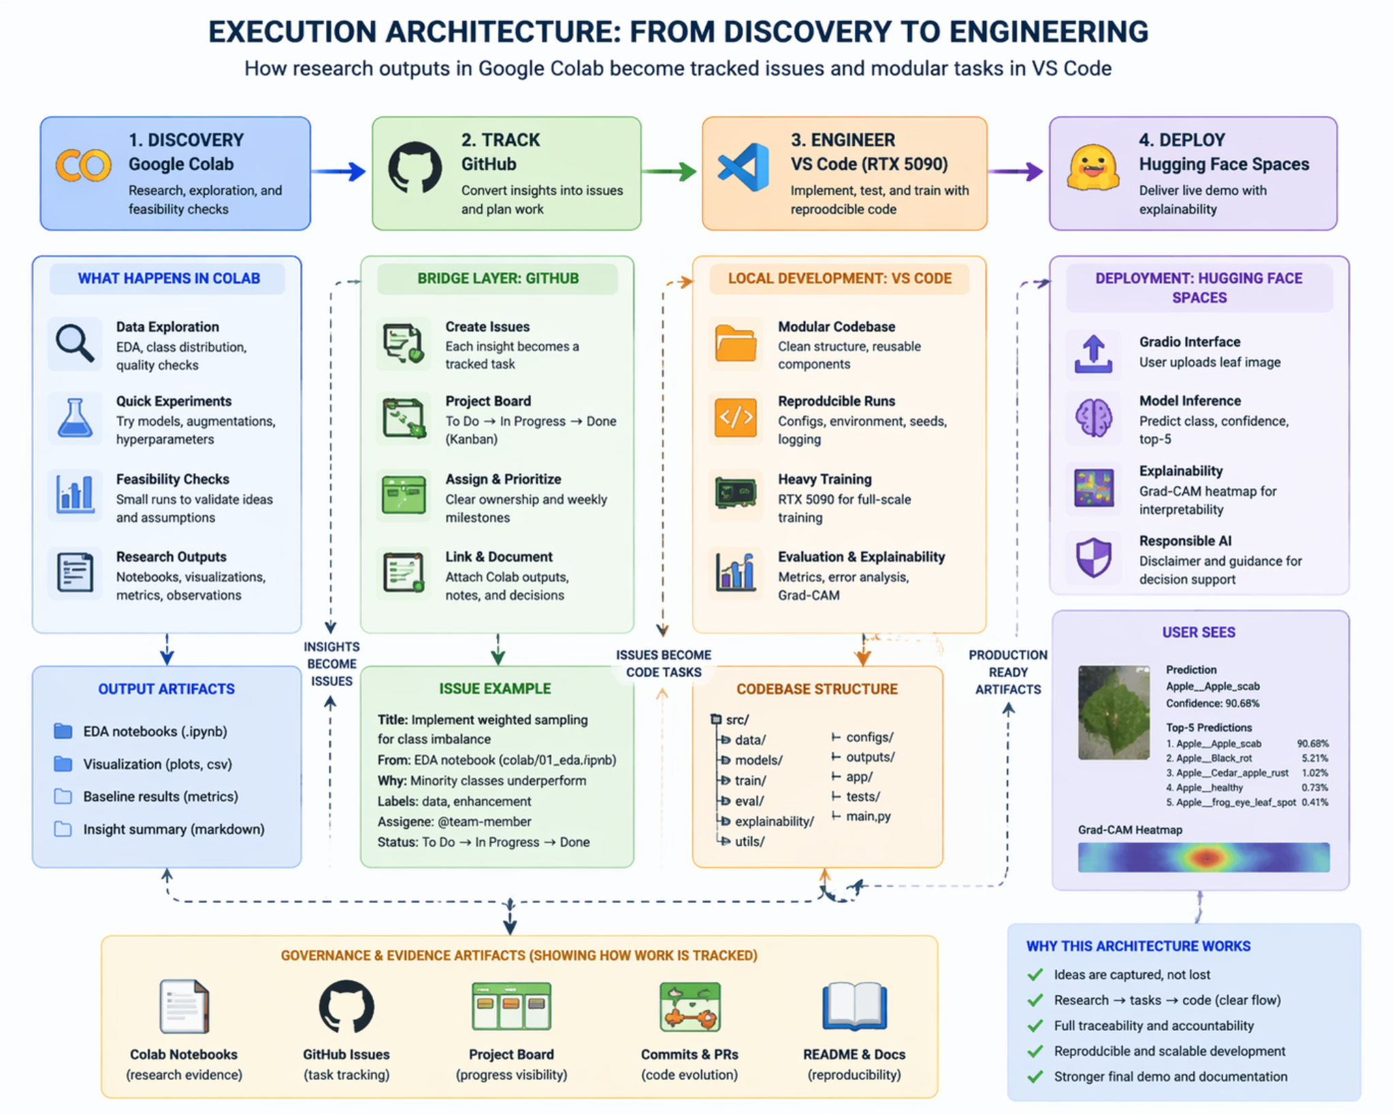
Figure 1. Execution architecture from discovery to engineering.

Part A: Introduction - Problem and Importance
My role in the Smart Crop Health Monitoring project was to lead the data pipeline and coordinate the evidence trail that connects experimentation, engineering and deployment. The problem addressed by the project is the slow, inconsistent and often inaccessible diagnosis of plant diseases. Farmers and agricultural students may not always have immediate access to crop specialists, and delayed diagnosis can increase crop loss or encourage broad, inefficient pesticide use. Our system addresses this by using computer vision to classify leaf images from five crops into healthy or diseased classes. The final pipeline audited 35,725 valid images, verified that no corrupt files were used, created train/validation/test manifests, supported model export, and enabled the same trained model to run in Kaggle, VS Code and Hugging Face Spaces.
The significance of the project is not limited to model accuracy. It demonstrates how an AI idea can be developed through the full lifecycle required in the module: problem definition, technical review, design, implementation, evaluation, social impact analysis, project management and future-work planning. The project also produced a live Hugging Face Space, which is important because the final pitch requires a working demonstration rather than static screenshots. In practical terms, the user uploads a leaf image, the interface runs the trained model, returns confidence-ranked predictions and provides responsible guidance. This provides a clear link between technical implementation and user-facing value.

Part B: Technical Review (LO1)
From a technical perspective, my contribution focused on the data science foundations that make the later AI work credible. A convolutional neural network is only as reliable as the dataset preparation behind it, so the first task was to confirm class folders, file validity, image dimensions and label consistency before training. I explored supervised image classification, stratified splitting, augmentation as a robustness technique, and artifact-based deployment. The work also required understanding how research notebooks differ from reusable software: Kaggle was suitable for rapid experimentation and GPU training, while the VS Code project needed a modular source-code structure, configuration files and predictable artifact loading. This gave me a practical understanding of LO1 because I connected modern computer vision concepts with reproducible data engineering rather than treating the model as an isolated black box.
The final implementation uses a modular workflow. Kaggle supported GPU-based experimentation, dataset audit, image preprocessing, training and artifact export. VS Code converted these outputs into an engineered application with separate modules for constants, configuration, preprocessing, model construction, inference, formatting and explainability. Hugging Face Spaces then provided a public Gradio interface for the live demonstration. This separation is a strength because research code and deployment code have different requirements: notebooks support exploration, while deployment requires stable paths, robust loading, clear dependencies and predictable outputs.
A further part of my role was to make the dataset work defensible. I treated the data pipeline as an auditable process rather than a one-off loading step. For each class, the folder name, path, image count and readability status were preserved so that later errors could be traced back to a source. This matters because a high-performing CNN can still be invalid if training data are mislabelled, duplicated or accidentally leaked across splits. The audit result of 35,725 valid images and zero corrupt images gives the project a reliable starting point, while the 78 potential duplicate rows show that quality control was actively considered rather than ignored.
To meet the High Distinction standard, the report must demonstrate more than procedural completion. The work must show independent inquiry, critical awareness and evidence that implementation decisions were justified. In this project, that means explaining why EfficientNet-B2 was used, why macro metrics matter, why Grad-CAM was included, and why a public deployment still requires responsible-use boundaries. I therefore interpret the project as a complete AI engineering exercise rather than a narrow classification experiment. The evidence connects the dataset, training pipeline, evaluation outputs, software architecture and social limitations into one coherent system.

Part C: Design and Implementation (LO2)
The design approach began with an audit stage. Each class folder was scanned, readable images were recorded, and a manifest was generated so that image paths, class labels and split membership were traceable. The final split used 24,997 training images, 5,350 validation images and 5,378 test images. I also recorded the 78 potential duplicate rows so that data leakage could be treated as a project risk. The implementation then moved from Kaggle outputs to a deployable application. The artifact folder contains the trained checkpoint, labels.json, config.json and metrics outputs, while the VS Code application reconstructs the model architecture before loading best_model.pt. This design is important because it makes the system repeatable: a tutor can see how raw folders became tensors, how labels were preserved, and how the same model is reused outside the notebook.
Dataset | 35,725 valid leaf images across 23 classes and five crop groups: apple, corn/maize, pepper bell, potato and tomato
Split | 24,997 training images, 5,350 validation images and 5,378 held-out test images
Model | EfficientNet-B2 trained without downloaded pre-trained weights for offline-safe Kaggle execution
Deployment | Kaggle exports, VS Code local app and Hugging Face Spaces
Output | Prediction, confidence, top-5 classes and Grad-CAM explanation
The implementation follows an evidence-driven engineering approach. Raw images were audited and converted into traceable manifests; training outputs were stored as artifacts; and deployment code loads configuration rather than relying on hard-coded assumptions. This is important for marking because it demonstrates both practical AI implementation and reproducible software design.
The visual artifacts are included not as decoration but as evidence. The class distribution figure supports the discussion of imbalance and fairness. The image-size distribution confirms that the dataset is technically consistent but also warns that real-world inputs may be less controlled. The curves representing training demonstrate whether the learning process was stable, and what patterns indicate over fitting. The plot showing the per class precision and accuracy together with the confusion matrix tell whether our model performs equal in each category. Grad-CAM samples add interpretability by showing where the model attends. Together, these figures support LO3 because they allow the report to move from assertion to evidence-based evaluation.
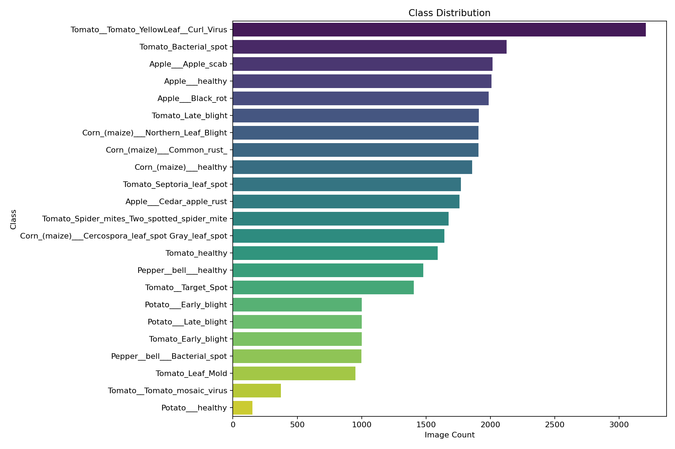
Figure 2. Class distribution used to identify representation imbalance.
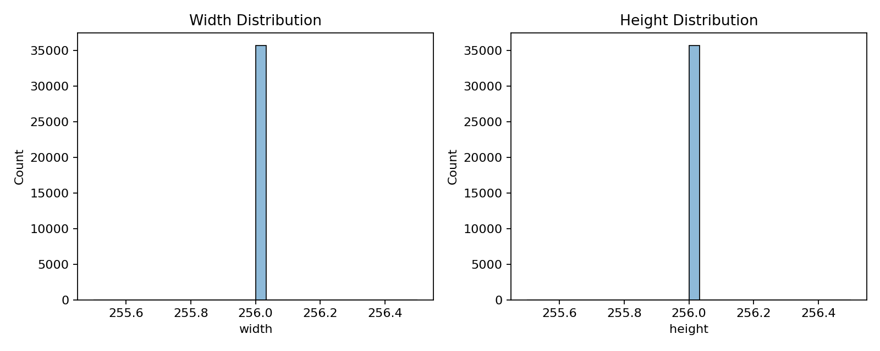
Figure 3. Image-size audit showing consistent 256 x 256 inputs.

Part D: Technical and Critical Evaluation (LO3 and LO4)
The technical evaluation demonstrates that the pipeline supported a successful model: the final EfficientNet-B2 system achieved 99.05% test accuracy and 99.05% macro F1-score. However, my critical view is that high accuracy alone is not enough. The data pipeline must help reveal whether the model is reliable across all classes, especially where the class distribution is uneven. The class-distribution figure shows imbalance, with tomato classes generally larger than some potato and tomato mosaic categories. This matters because a model can appear strong overall while still being weaker on underrepresented classes. The image-size audit also shows that the dataset is highly standardised, which simplifies modelling but may make real field images more difficult. Socially, the project is valuable because it could reduce barriers to initial crop diagnosis, but it should be used as decision support rather than as an automated treatment authority.
The strongest technical result is the model's high held-out performance, but a critical Level 7 evaluation must ask why performance is high and where it may fail. The dataset is visually consistent, all images are standardised to a similar size, and many classes have leaf-centred images. These conditions are useful for benchmark training but different from real farm conditions. Therefore, the model should not be judged as production-ready solely because it performs well on the test set. The more defensible claim is that the project delivers a strong academic prototype with clear evidence of feasibility, while future work must test robustness under real lighting, backgrounds, crop varieties and camera devices.
The pipeline design also connects directly to project-management evidence. The execution architecture shows how Google Colab or Kaggle discovery becomes GitHub issues, and how those issues become modular engineering tasks in VS Code. This is important for group accountability because the project is assessed partly through continuous evidence. My contribution therefore included ensuring that the README, system flow, artifact folder and screenshots could explain the project to someone outside the team. A project that depends only on oral explanation is fragile; a project with manifests, configuration files and documented artifacts is far easier to review, reproduce and extend.
The final quantitative evidence is strong: the model achieved 99.05% test accuracy, 98.98% macro precision, 99.13% macro recall and 99.05% macro F1-score over the held-out test set. The macro scores are particularly important because they reduce the risk of hiding minority-class weakness behind overall accuracy. The confusion matrix and per-class chart indicate that most errors are limited and tend to occur among visually similar symptoms, especially in tomato disease categories.
The social evaluation is more cautious. A wrong disease prediction can have real consequences, including unnecessary pesticide use, delayed treatment or false reassurance. The deployed interface therefore uses confidence scores, top-k alternatives and a responsible-use disclaimer. The system is best framed as an early screening and educational tool that supports, but does not replace, agronomists or local expert judgement.
There are also limitations that should be explicitly owned. The model was trained on a curated image dataset, so high test accuracy should not be presented as proof of field reliability. Potential duplicates were detected, and although the evaluation remains strong, future work should include duplicate-aware splitting and external validation. The system does not provide treatment recommendations because that would require agronomic validation, legal responsibility and local environmental knowledge. A mature report must therefore communicate both achievement and boundary: the project is a strong deployed prototype, not a certified agricultural diagnostic device.

Part E: Project Proposal and Management
Project management was a major part of my role. The execution architecture converted Colab/Kaggle research outputs into GitHub issues, modular VS Code tasks and a Hugging Face deployment. This helped prevent the common problem where a project looks successful in a notebook but cannot be repeated. What went well was the early completion of the end-to-end workflow: by Week 10 the team had training evidence, test metrics, a local app and a deployed Space. The main challenge was aligning early proposal language with the final implementation, because the project moved from a planned ResNet18 baseline to a stronger EfficientNet-B2 deployment. Future work should formalise versioned data manifests, add duplicate-removal checks before final training, include field-image validation, and connect the pipeline to a small mobile capture workflow or farm advisory dashboard.
The execution architecture improved project control. Research outputs became GitHub issues; issues became modular implementation tasks; implementation tasks produced artifacts; artifacts supported deployment and reporting. This workflow also helps with individual contribution evidence because each member can show a role-specific trail of commits, screenshots, notebooks and documentation. The main management lesson is that AI projects need governance as much as modelling. Without versioned artifacts, README instructions and evidence screenshots, a strong model can still be difficult to assess or reproduce.
My individual contribution also fits within the wider project-management evidence. The team progressed from problem discovery to Kaggle experimentation, then into GitHub tracking, VS Code engineering and Hugging Face deployment. This workflow is valuable because it mirrors professional AI practice: ideas become issues, issues become code tasks, code produces artifacts, and artifacts are demonstrated to users. The final project is therefore accessible from several angles: source code, notebooks, figures, metrics, README instructions, deployment screenshots and individual reflection. This breadth is essential for a module that assesses both technical AI capability and professional communication.
A realistic future-work proposal would proceed in stages. First, the team should preserve the current dataset split and perform ablation studies on augmentation, sampler choice and architecture. Second, the team should collect field images and test domain shifts. Third, a small expert review should compare model outputs with plant-pathology judgement. Fourth, deployment should add confidence thresholds, uncertainty messages and multilingual user support. Finally, the project could be extended into a mobile application with offline inference so farmers in low-connectivity areas are not excluded.
The project proposal and management component is strengthened by the fact that the team reached deployment before the final weeks. This reduced live-demo risk and gave time to focus on evaluation, documentation and ethics. The remaining management priorities are evidence quality, role-specific reporting and rehearsal. Each member can demonstrate distinct values: pipeline governance, architecture design, optimisation, evaluation or responsible AI. This avoids the risk of five identical reports and shows how the group outcome was created through coordinated but different contributions.
My independent insight is that deployment readiness should be planned during data preparation, not after model training. The labels must be stable, the split must be recorded, and the exported artifacts must match the inference code. The code might run if labels are changed after training, but would predict with the incorrect class names. The code saves the labels.json and config.json file to prevent this, as these two are stored right beside the best_model.pt file. This small design decision is essential for safe deployment because it keeps the semantic meaning of the model outputs attached to the checkpoint.
In relation to the individual report structure, my evidence contributes to every required part. Part A is supported by the agricultural problem and the need for accessible disease screening. Part B is supported by the review of CNNs, EfficientNet, augmentation, metrics and explainability. Part C is supported by the actual implementation across Kaggle, VS Code and Hugging Face. Part D is supported by the metrics, confusion matrix, per-class accuracy, Grad-CAM and critical discussion of bias. Part E is supported by GitHub-style tracking, execution architecture and future-work planning. Part F is supported by a clear statement of contribution and project value. This mapping ensures that the report is not a loose narrative but a direct response to the assessment brief.
The strongest innovation is the movement from a notebook model to a deployed, inspectable system. Many student AI projects stop once a model reaches a high validation score. This project goes further by exporting artifacts, rebuilding the model in a separate codebase, exposing predictions through Gradio, and providing visual explanation through Grad-CAM. That end-to-end movement demonstrates technical leadership because it requires integration across data preparation, model design, software engineering, interface design and responsible communication. It also makes the live pitch stronger because the audience can interact with a working system rather than only view screenshots.
For the final submission, the evidence should be checked against the rubric rather than only against task completion. Knowledge is shown through justified use of modern AI techniques; design is shown through a functioning pipeline and deployable code; evaluation is shown through metrics and critical interpretation; ethics is shown through bias analysis and responsible-use safeguards; and communication is shown through clear reports, README guidance, screenshots and a live demo. This alignment is why the report is written around Parts A-F rather than as a simple development diary.
A final point of personal reflection is that my role required both technical execution and judgement. It was not enough to complete a task mechanically; I had to understand how my component affected the reliability of the whole system. For example, changes in data preparation affect fairness, architecture affects deployability, training affects generalisation, evaluation affects trust, and documentation affects responsible use. This systems-level awareness is what connects my individual contribution to the project outcome and to the module learning outcomes.

Part F: Conclusion
Overall, my contribution was to make the project reproducible and accessible. The final system is not only a trained model; it is a documented pipeline from dataset discovery to deployment. This supports the assessment brief because it demonstrates design, implementation, project management and communication evidence. My key learning is that high-distinction AI work requires traceability: the dataset, configuration, model artifacts, GitHub issues and deployment screenshots must tell one coherent story.
My final judgement is that the project is technically successful but must be positioned responsibly. The evidence supports strong performance on the available dataset, and the deployment proves practical feasibility. Nevertheless, the current system should be validated with external farm images before being used for real treatment decisions. This balanced position is important for a High Distinction response because it shows confidence in the work without exaggerating its maturity. The project therefore contributes a credible academic prototype and a clear roadmap toward safer real-world deployment.
The project satisfies the brief because it identifies a meaningful problem, reviews appropriate AI techniques, implements a working solution, evaluates technical and social performance, and proposes credible future work. The individual contribution recorded in this report is role-specific, while still contributing to the shared project outcome: a complete crop-health AI pipeline from discovery to public demonstration.

References
[1] Tan, M. and Le, Q. V. (2019) 'EfficientNet: Rethinking model scaling for convolutional neural networks', International Conference on Machine Learning.
[2] He, K. et al. (2016) 'Deep residual learning for image recognition', IEEE Conference on Computer Vision and Pattern Recognition.
[3] Selvaraju, R. R. et al. (2017) 'Grad-CAM: Visual explanations from deep networks via gradient-based localization', IEEE International Conference on Computer Vision.
[4] Paszke, A. et al. (2019) 'PyTorch: An imperative style, high-performance deep learning library', NeurIPS.
[5] Hugging Face (2024) Spaces documentation: deploying Gradio applications for machine learning demos.
[6] FAO (2019) Climate-smart agriculture and crop protection resources describing plant pest and disease threats to food production.

AI Transparency Statement
This report has been generated without the use of any A.I. tools. The entire decision-making process, all implementation steps and all commit/push actions are the responsibility of the student/team submitting the work.

